My Child’s Profile Child’s Name: DOB:

Problem / Treatment / History Log

Keep a running log of your child’s medical history. Your child’s history is important to anyone providing services to your child. Keep accurate and precise data on all illnesses, injuries, procedures, hospitalizations and office visits.
Need more copies?
Contact the Northern Regional Center at 1-866-640-4106.
Website: www.northernregionalcenter.org
Email: specialneedsinfo@co.marathon.wi.us

Adapted from Alameda Medical Home Project for Children with Special Health Care Needs, California, 2000.
Date | Problem  (Illness, injury, procedure (x-rays/labs), hospitalization (in-out-patient, ER), or office visit (dental, medical specialty). | Attending Physician | Location | Results/  Outcomes
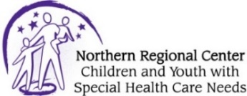

My Child’s Profile Child’s Name: DOB:

Problem / Treatment / History Log

Date | Problem  (Illness, injury, procedure (x-rays/labs), hospitalization (in-out-patient, ER), or office visit (dental, medical specialty). | Attending Physician | Location | Results/  Outcomes
Need more copies?
Contact the Northern Regional Center at 1-866-640-4106.
Website: www.northernregionalcenter.org
Email: specialneedsinfo@co.marathon.wi.us

Adapted from Alameda Medical Home Project for Children with Special Health Care Needs, California, 2000.

