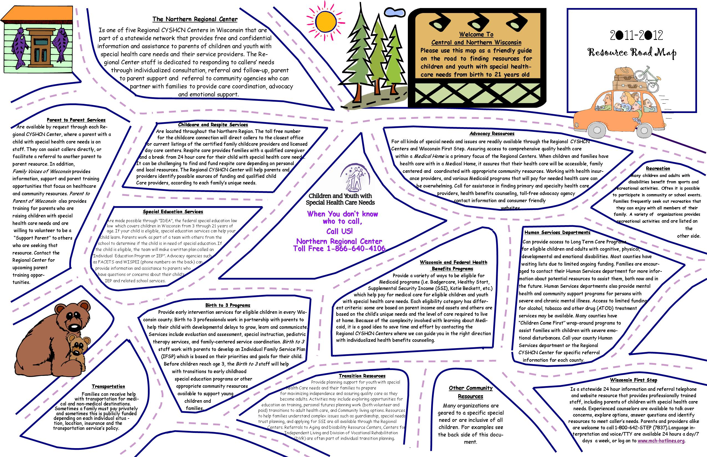

**Central/Northern Wisconsin Resources for Children and Youth with Special Health Care needs**

**ADVOCACY**

**ABC For Health, Inc.** (benefits counseling and legal services).. **608-261-6939**

**(DRW) Disability Rights Wisconsin**…….…………………...…. **800-928-8778**

**WI Facets-Educational Support** ………………………………….**877-374-4677**

**AT-HOME SUPPORT (RESPITE PERSONAL CARE RESOURCES)**

**Midstate Independent Living Consultants Inc.**..……….....**800-311-5044**

**O**p**portunity, Inc**……………………………………………………..**800-472-4408**

**Childcare**

**Opportunity, Inc.** (Tyler’s Home)………………………....**800-472-4408**

**Childcare Connection**…………………… …………….…...**800-848-5229**

**wondERFULLY MADE CHILD DEVELOPMENT CENTER**.….**715-355-4769**

**PROJECT BRIDGES (**Serving Florence, Forest, Oneida, Vilas

& Tribal Communities of Lac Du Flambeau, Mole Lake, StoneLake…………………….………………………………..….….**800-470-5833** [**www.dcf.wisconsin.gov/childcare**](http://www.dcf.wisconsin.gov/childcare)

**www.cerrcw.org ...www.SupportingFamiliesTogether.org**

**MARATHON CO. EARLY INTERVENTION FOR INFANTS**

**AND YOUNG CHILDREN (BIRTH TO THREE)**

**Birth to Three**..............................................................................**800-236-0501**

**Marathon Co**………………………………………………………....**715-848-4580**

**HEAD START** ………………………………………………………..**715-845**-**2947**

**Early Childhood Learning Center**.............................................**715-848-0166**

**AC Kiefer Educational Center**………………….………………....**715-261-0265**

**HEALTH DEPARTMENT**

**715-261-1900**

Marathon County Health Department………...**TOLL FREE**.…...**866-640-4106**

**MARATHON COUNTY DEPT OF SOCIAL SERVICES**

**General Information**……………………………….……………..**715-261-7500**

• Child Protective Services

•  Children with disabilities

•  Economic Support

**INFORMATION REFERRAL AND ASSISTANCE**

**United Way (24 hour information and referral service ………….…...2-1-1**

**Wisconsin First Step**

**(24 hour information and referral service)**…......……....….…**.800-642-7837**

**PARENTING SUPPORT**

**Parent to Parent of WI**…………………………………..………….**888-266-0028**

**Family Voices of WI….608-220-9598**

**Wisconsin Family Ties**……………………………………………..**800-422-7145**

• Support for families with children/adolescents with emotional, behavioral, and mental disorders

**Family Resource Center**…………………………………………...**715-845-6747**

**Wisconsin Parents of Blind Children…………………………..**.**608-563-4708**

**LOCAL PARENT SUPPORT GROUPS**

**Autism Society Central WI Chapter**…………………….………..**715-845-5524**

**Down Syndrome Family Network admin@gettindowncentralwi.com**

**Epilepsy Foundation of Central & Northeast WI**

**…………………………………..www.epilepsyfoundation.org/enewisconsin**

**United Cerebral Palsy of North Central WI……………………..715-842-8700**

**RECREATION, SPORTS AND SUMMER PROGRAMS**

**Special Olympics, Wisconsin**…………………………………….**.800-552-1324**

**Easter Seals WI**….…………………………………..…………….**800-422-2324**

•  Respite and recreation

**Stable Hands, Inc…**…………………………………….…………..**715-359-6046**

• Therapeutic riding and Equine Assisted Activities

**Wisconsin Lions Camp**…………………………………………….**715-677-4764**

• Camp for blind, deaf, cognitively disabled and diabetic children

**SPECIAL EDUCATION:PARTNERSHIP AND SUPPORT**

**DC Everest area School District**………………..**715-359-4221**

**Merrill Area School District…**………..……….…**715-536-9421**

• Special Services

**Mosinee School District…………………………..715-693-2530**

**Wausau School District..**………….………..……..**715-261-0535**

• Special education/pupil services

**CESA 9—Central/Northern WI**………………..**608-224-5395**

• Stratford, Edgar, Marathon City, Athens, Mosinee, DC Everest area, Wausau, Merrill, Antigo, Rib Lake, Elcho, Tomahawk, Prentice, Rhinelander, Three Lakes, Lakeland Northland Pines, Phelps

**CESA 12—North/NW**……………………..………..**608-224-5395**

• Phillips, Winter, Park Falls, Butternut, Mercer, Hayward, Glidden, Hurley, Mellen, Drummond, Northwood, Solon Springs, Superior, Maple, South Shore, Washburn, Ashland, Bayfield

**STRESS, CRISIS AND MENTAL HEALTH INTERVENTION**

**North Central Health Care Center**…………...**715-848-4600**

**Crisis Center**………………..……………………………**715-845-4326**

**Northwoods Alliance**………………………..……..**715-848-4500**

**Central WI Counseling Associates**…..……....**715-424-6960**

• Domestic Violence

**SPECIALIZED TRANSPORTATION**

**MARATHON COUNTY**

* Abby Van Lines…………………………….8**00-236-8438**
* Ambu-Lift Transports…………………..**715-343-1804**
* American Cab……………………………….**715-355-0899**
* North Central Health Care……………**877-814-4668**
* Opportunity, Inc. ……………………….…**715-572-8821**
* Wausau Metro Ride (fixed route**)..715-842-9287**

**LANGLADE COUNTY**

For Elderly and Disabled Transportation….**715-627-6230**

**Specialized Medical Vehicle:**

* Antigo Vans**………………………………..715-627-0387**
* North Central Caravan**………………..715-623-2229**
* Freedom Vans………………………………**715-623-5906**

**WOOD COUNTY**

**Bus Service:**

On the first and third Friday of each month for rural residents of Central Wood County we have a bus that will take you shopping in Wisconsin Rapids or Marshfield.

**Volunteer Driver Program:**  
A volunteer driver will take you from your home to your medical appointment anywhere in Wisconsin for about 20 cents a mile.

**DAV Van:**

This service is FREE to veterans with medical appointments to any VA clinic in Wisconsin.

For assistance with your transportation needs please call **888-486-9545** and ask for transportation.

**OTHER TRANSPORTATION PROVIDERS IN THIS AREA ARE:**

Abby Vans Inc. [www.abbyvans.com](http://www.abbyvans.com).................**800-236-8438**

Ambu-Lift Transports …..…..………………………**715-343-1804**

Courtesy Carriers…………….………………………..**715-341-5599**

Opportunity Inc. www.balancinglives.org ………... 7**15-572-8821**

Specialized Transport

www. specialized[trans@tznet.com](mailto:trans@tznet.com)....……….**715-305-7384**

Wheels of Independence**……………………….…800-423-7818**

**Information, Assistance & Advocacy Resources For Families of Children and Youth**

**with Special Health Care Needs in Wisconsin**

**ABC for Health, Inc** – benefits counseling and legal services for families with children who are having problems financing healthcare

[www.safetyweb.org](http://www.safetyweb.org) **1-800-585-4222**

**The ARC –** **Wisconsin Disability Association** – Advocacy, support groups, training, information and referral for persons with cognitive disabilities [www.arc-wisconsin.org](http://www.arc-wisconsin.org) ……. …. .**1-877-272-8400**

**Birth to 3** – Wisconsin’s Early Intervention (IDEA-part C) program for children with special needs under age 3

[www.dhfs.wisconsin.gov/bdds/birthto3/index.htmb (Intake number is First Step) .**1-866-642-7837**](http://www.dhfs.wisconsin.gov/bdds/birthto3/index.htmb%20(Intake%20number%20is%20First%20Step)%09%09%09%09%09%20.1-866-642-7837)

**(CAP) - Client Assistance Program** – information and assistance to individuals who have a dispute with DVR

www.dwd.state.wi.uscap.htm 1-800-362-1290

**(CESA) - Cooperative Educational Service Agency**-provides training to families and assists districts

[www.http://dpi.wi.gov/cesa.htm **1-800-441-4563**](http://www.http://dpi.wi.gov/cesa.htm%20%09%09%201-800-441-4563)

**(DRW) - Disability Rights Wisconsin**-provides protection and advocacy for persons with disabilities in Wisconsin

[www.disabilityrighswi.org](http://www.disabilityrighswi.org) (TTY) 1-888-758-6049 **1-800-928-8778**

(**DPI) Wisconsin Department of Public Instruction: Special Education Team**-information on public education for children with special needs

www.dpi.state.wi.us … **1-800-441-4563**

Ask to be connected to a local district’s number in the community.

[www.dwd.state.wi.us/dvr/ 800-442-3477/TTY… **1-888-877-5939**](http://www.dwd.state.wi.us/dvr/%20%20%09800-442-3477/TTY…%091-888-877-5939)

**(DVR) Wisconsin Division of Vocational Rehabilitation** – state employment training program for individuals with disabilities living in the community. Eligible individuals may receive vocational evaluation and training and job placement assistance

[www.dwd.state.wi.wi.is/dvr/ 1-800-442-3477/TTY **1-888-877-5939**](http://www.dwd.state.wi.wi.is/dvr/%20%20%091-800-442-3477/TTY%20%091-888-877-5939)

**(FACETS) Wisconsin Family Assistance Center for Education, Training and Support** – provides free information and assistance to families

concerning parent and student rights and opportunities in education

www.wifacets.org 1-877-374-4677/TDD **1-414-374-4635**

**Family Support Program** – Provides information about services and resources, limited funding and linking with other families

<http://dhfswisconsin.gov/bdds/fsp.htm>. call WI First Step at ……………………………………………………………………………….**1-800-642-7837**

**Family Voices of Wisconsin** – A statewide grass roots training, information and advocacy network of families whose children have disabilities

or special health care needs

[www.wfv.org/ ............................................................................................................................................................ Barbara](http://www.wfv.org/%20%20............................................................................................................................................................%20Barbara) Katz **1-608-220-9598**

**(ILCs) Wisconsin Independent Living Centers** – Consumer-driven services to promote full participation in society of persons with disabilities.

Services include: health benefits counseling, assistive technology, peer support and advocacy

www.dhfs.state.wi.us/Disabilities/Physical /H Cs.htm...................................................call Wi First Step at…………………………..**1-800-642-7837**

**Head Start/Early Head Start-Child-** development program for children (0-6) of low income families. 10% of children enrolled have special needs

[www.whsaonline.org](http://www.whsaonline.org) **1-715-845-2947**

**Parent to Parent of Wisconsin** – provides parent support to parents of children with special needs through a one-to-one connection with

another parent who has a similar experience and knows firsthand about the feelings and realities that come with having a child with special needs

http//www/familyresourceconnection.org ……………………………………………………………………………………………………..**1-888-266-0028**

**Respite Care Association of Wisconsin** – promote, support and expand quality respite care resources across the lifespan for families

**……………………………………………………………………………………………………………………………………………………..**1**-866-702-7229**

**Social Security** – financial benefits for children meeting income and asset eligibility criteria

[www.ssa.gov](http://www.ssa.gov)..................................................................................................................................................................................... **1-715-845-1321**

**Supporting Families Together Association,** formerly (CCR&R) – network of community bases child care resources and referral agencies

[www.wisconsinccrr.org](http://www.wisconsinccrr.org) ……………………………………………………………………………………………………………………….. **1-888-713-5437**

(**WATI) Wisconsin Assistive Technology Initiative**-maintain lending library of assistive technology devices, provides training and consultation

provides evaluation of students related to assistive technology

www.wati.org.......................................................................................................................................................................................**1-608-758-6232**

**Wisconsin Developmental Disabilities Board, formerly (WCDD)** – provides training and advocacy resources

www.wi-bpdd.org.................................................................................................................................................................................**1-888-332-1677**

**Wisconsin Family Ties –** Network of Family Advocates who provide support groups, peer-mentoring, training, advocacy, information and

referral for families that include children and youth with mental, emotional, behavioral or substance abuse disorders

www.wifamilyties.org...........................................................................................................................................................................**1-800-422-7145**

**Wisconsin First Step** – 24 hour information and referral service to assist Wisconsin families who have children with special needs

www.mch-hotlines.org.........................................................................................................................................................................**1-800-642-7837**

**Wisconsin Regional Children and Youth with Special Health Care Needs Centers (CYSHCN) –** a network of information and assistance services so all families of children and youth with disabilities or special health care needs and providers have access to complete

and accurate information

Contact Wisconsin First Step……………………………………………………………………………………………………………………**1*-*800-642-7837**

**(WSPEI) Wisconsin Statewide Parent Educator Initiative**- parent liaisons that work with families, educators and school districts through

the CESA’S to promote positive partnership and free consultation to families of children with special educational needs

www.wi-pec.net contact person>>> Evelyn Azbell……………………………………………………………………………………………**1-715-820-1667**

**HEALTH COVERAGE**

**ACCESS** – Quick and easy way to see if you might be able to get help through Wisconsin’s health, nutrition and other programs

[www.access.wi.gov](http://www.access.wi.gov)

**Katie Beckett** – a way to obtain Medicaid for children not eligible for other Medicaid programs because of income/assets requirements

[**www.dhfs.state.wius/bdds/kbp/ …………………………………………………………………………………………………………… 1-608-266-1865**](http://www.dhfs.state.wius/bdds/kbp/%20%09%09%091-608-266-1865)

**Medicaid (Medical Assistance, MA Title 19, BadgerCare Plus, Katie Beckett, SSI HealthCheck) Recipient Hotline-**information about

recipient eligibility rights, covered benefits, providers, problems with bills, etc. for those with Medicaide. …………………………..**1-800-362-3002**

**Medicaid Ombudsmen** – assistance with appeals, complaints, billing problems etc. for Medicaid HMO enrollees

**WIC ( nutrition program) –** food and education for pregnant and nursing women, food/formula for young children; breastfeeding support to eligible families ………………………………………………………………………………………………………………………………….**1-800-722-2295**